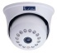
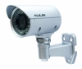
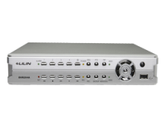
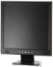
Indoor Camera Outdoor Camera DVR / NVR Monitor

Customer Name | Mr. Romesh Devid
Drawing Title | CCTV
Issue No | 123-15
Issue Date | 20/5/2015
Revision No
Revision Date
Created By | Ajith Fernando
Approved By
